Experiment-9

Aim
To implement image scaling techniques by resizing an image to larger and smaller dimensions using Python and OpenCV.

Procedure
- Import the OpenCV library.
- Read the input image using cv2.imread().
- Obtain the original image dimensions.
- Resize the image to a larger size using cv2.resize().
- Resize the image to a smaller size using cv2.resize().
- Display the original, enlarged, and reduced images.

Code
import cv2
img = cv2.imread("image.jpg")
if img is None:
print("Error: Image not found")
exit()
bigger = cv2.resize(img, None, fx=2, fy=2,
interpolation=cv2.INTER_LINEAR)
smaller = cv2.resize(img, None, fx=0.5, fy=0.5,
interpolation=cv2.INTER_AREA)
cv2.imshow("Original Image", img)cv2.imshow("Bigger Image", bigger)cv2.imshow("Smaller Image", smaller)
cv2.waitKey(0)cv2.destroyAllWindows()

Sample Input
An image named image.jpg.

Sample Output
- Original image: Displays the input image at its original dimensions.
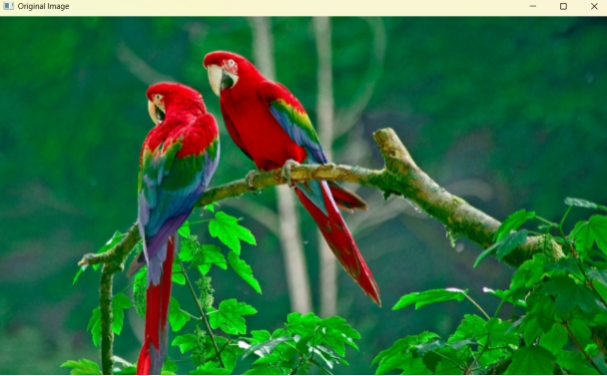
- Bigger image: Displays the image enlarged to twice its original width and height.
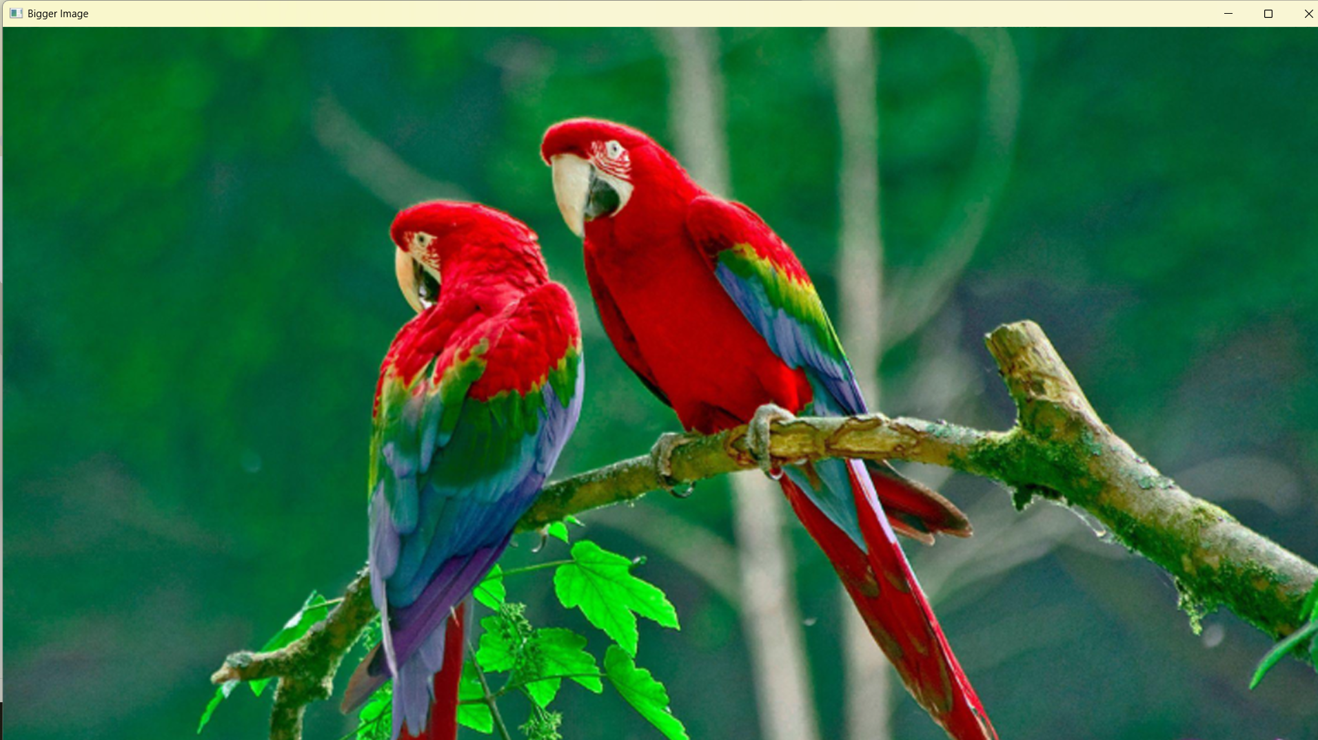
- Smaller image: Displays the image reduced to half its original width and height.
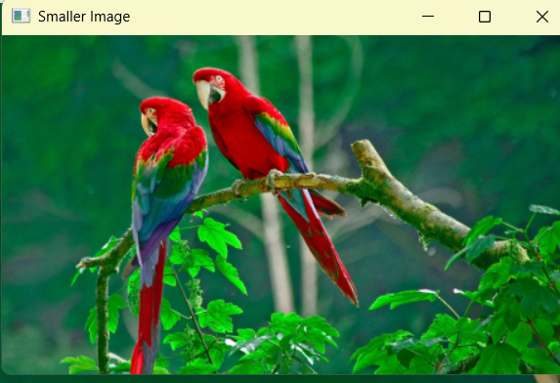

Result
Thus, image scaling was successfully performed by resizing the input image to larger and smaller sizes using Python and OpenCV.

